BRONX COMMUNITY COLLEGE

of the City University of New York

Committee on Academic Standing
Minutes of September 22, 2021 (web conference [Zoom])

Present: Rasheed Allen (Bio), Angel Calderon (Stu; logged out after 3pm), Teresa Fisher (CommAS), Kenneth Flowers (SGA; logged out after 3pm), Anthony Gatto (A&M), Janet Heller (HPER), Paul Jaijairam (Bus), Noah Jampol (Eng), Mehdi Lejmi (Math), Eugene Mananga (Eng Phy Tech), Octavio Melendez (Adv, OAA), Stephen Powers (Edu), Wladyslaw Roczniak (Hist), Elena Robin (SGA; joined at 3:13pm), Marjaline Vizcarrondo (Soc Sc), James Watson (Library)
Present Alternates: Nefertiti Cano (Nur) – seated, Gregory Cobb (Soc Sci; logged in around 2:45pm), Carlos Cruz (CommAS), Ivan Horozov (Math), Z. Ingram (World Lang) -- seated, Edward Lehner (Edu; logged out by 2:40pm), Vianela Mejia (Reg) – seated, James Simpson Jr. (Bus; joined at 3pm)
Guests: Cheryl Byrd (Academic Appeal Agent), Jessica Cabrera (ASAP), Cynthia Suarez-Espinal (CD), Alexander Ott (OAA)
Absent/Excused: Laurel Cummins (World Lang), Vivian Rodriguez (Nurs), Sheldon Skaggs (Chem); (also need 2 more student reps)

- Call to Order: At 2:08 P.M., meeting called to order by V. Mejia. The meeting was recorded beginning at 2:13pm (after the elections were completed).
- Election of Chair and Recording Secretary: O. Melendez led the election of Chair and Recording Secretary. S. Powers was unanimously elected as Chair. T. Fisher was unanimously elected as Recording Secretary. There were no other nominations for either position. J. Watson and E. Rubin arrived after the elections.
- Approval of the May 12, 2021, minutes: The minutes from 05/12/21 were approved by the 12 seated members present who were at that meeting.
- Student Appeals and Fall sub-committee dates: C. Byrd updated on the summer appeals. 210 appeals were received: 135 were granted, 75 were denied. Denials included unnecessary/inexplicable waivers of dismissal (as no students were dismissed since the pandemic began) and those due to insufficient or incorrect paperwork. C. Byrd did a lot of follow up with those latter students to help them correct their appeals. The appeal process remains online.
- Prior Learning Assessment (PLA) or Credit for Prior Learning (CPL): A. Ott updated on the work done over the summer on this initiative. Lots of work is being done to determine equivalencies as well as input them into the system. It is estimated this may affect around six students a year at BCC. A. Ott shared the Transfer Explorer link with members, as the information will be housed there: https://explorer.cuny.edu/.
- Dean’s List and President’s List Revisions: O. Melendez requested members to join a sub-committee to review the criteria to see if the Dean’s List and President’s List should be revised to be cleaner/clearer and more academically appropriate, particularly given the grading changes that have occurred over the past number of years. As the Dean’s List and President’s List criteria are in the codification, they fall under CAS’s purview. S. Powers suggested that Edwin Roman (OAA) and the Registrar would be helpful to include in the discussions. A. Ott also mentioned the need to have student honors reflected on student transcripts.
- The CUNY Grading System: S. Powers updated members of CUNY grading policy changes as per the 5/22/2021 CUNY memo (attached). Some will require edits to the codification in order to meet the revised guidelines. One change is the removal of the academic penalty for the WU grade effective Fall 2021 (not retroactive). This will reduce the WU appeals the committee hears. The WU will now carry the same potential financial aid impact as the WA, WN, and WD do. As a reminder, the WD is when a student drops a course within the first three weeks of the semester, before the VOE (verification of enrollment). S. Powers reminded members to share this information with their departments. The other grading change of note regards the final day to submit grades and its impact on INC/FIN grades, particularly the ability to change them. Prior policy was that INC grades could be resolved up to the time a student graduates. The new policy says they have only a year from when the INC was granted. V. Mejia noted that it appears students can appeal after a year, but it has to go through a committee to approve it. T. Fisher started the codification changes already, which will be sent out to members. This is informational only, no voting needed.
- Late Start Sections: S. Powers updated the members on the academic and financial implications of the late start course sections. Approximately 112 courses were moved from a 8/25 start to a 9/9 start for students late to register. However, S. Powers noted the late start classes had only had 6 days instead of 3 weeks to demonstrate attendance/participation before the VOE roster was submitted (the deadline is firm as it’s set by the government, not the College), raising an equity concern. Students do have the ability to request a reversal of the WN with the course instructor. V. Mejia reminded of the existing concern regarding timely submission of the VOE rosters by faculty as another challenge to equity. S. Powers asked members to bring this discussion back to their departments – equity with respect to how participation/attendance is measured/reported for the VOE (for example, making sure there is an academic assignment within the first week, especially for the late start; and make sure Blackboard is open prior to the first week of classes) and the late start concern. V. Mejia will follow up with Karen Thomas to see what the numbers of late start versus regular start WNs are. C. Byrd noted many late start students were new students thus still figuring out all the ins and outs of BCC as well as those with in-person classes also had to get through the vaccine-proof process to get on campus. Access to Blackboard also takes time, also delaying participation. C. Suarez-Espinal reminded that students will incur a financial penalty for WNs. J. Heller noted how the challenge of CPR 10, which starts 7-weeks into the semester, was addressed with a policy of submitting the VOE as all attended, then revising it, as needed, once the course actually started to retroactively apply the WN. Discussion continued.
- COVID campus policies: S. Powers opened discussion about campus access and implications for students who will be dropped from in-person classes if they haven’t completed it.
- Adjournment: 3:55 p.m.

Meetings are held on the 2nd and 4th Wednesday of the month. The next meeting of the 2021-2022 academic year is October 13, 2021. Remaining Fall 2021 dates are: 10/27, 11/10, and 12/8.

Respectfully Submitted,
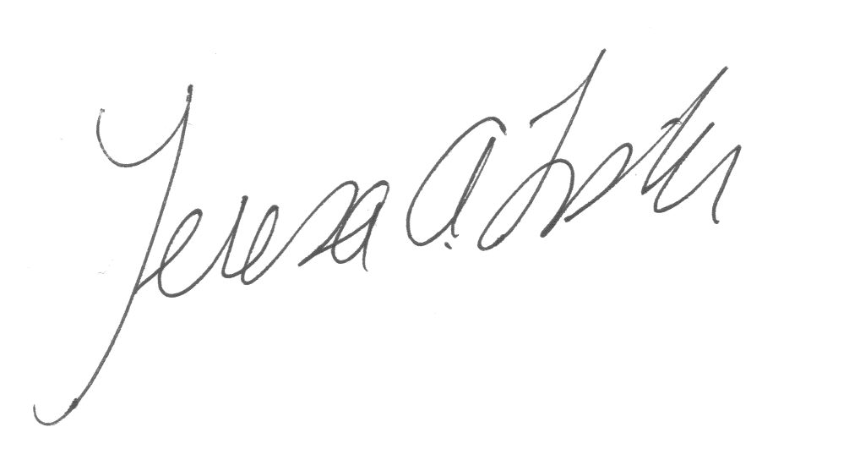
Teresa A. Fisher, Recording Secretary

Handouts: agenda, CUNY 5/22/21 grading policy memo
Recording: https://us02web.zoom.us/rec/share/IjAU-KiTkdaUITXERew09AZ_JerzKjEw8HIp3mmnOY4Tz8u3CXMIbT1aGcqeMLzL.erFB_7t6KqXsi4WM Passcode: r?.%t@0W

