BRONX COMMUNITY COLLEGE

of the City University of New York

Committee on Academic Standing
Minutes of November 10, 2021 (web conference [Zoom])

Present: Rasheed Allen (Bio), Angel Calderon (Stu; arrived at 2:16pm), Laurel Cummins (World Lang), Teresa Fisher (CommAS), Anthony Gatto (A&M), Janet Heller (HPER), Kamal Ismail (Chem), Paul Jaijairam (Bus), Noah Jampol (Eng), Mehdi Lejmi (Math), Eugene Mananga (Eng Phy Tech), Octavio Melendez (Adv, OAA), Stephen Powers (Edu), Wladyslaw Roczniak (Hist), Vivian Rodriguez (Nurs; left at 2:52pm), Marjaline Vizcarrondo (Soc Sc), James Watson (Library)
Present Alternates: Nefertiti Cano (Nur; joined at 2:30pm), Carlos Cruz (CommAS), Gregory Cobb (Soc Sc), Edward Lehner (Edu), Anita Rivers (Reg) -- seated, James Simpson Jr. (Bus), Soosairaj Therese (Chem), Stella Yeboah (SGA) -- seated
Guests: Cheryl Byrd (Jessica Cabrera (ASAP), Cynthia Suarez-Espinal (CD), Alexander Ott (OAA)
Absent/Excused: Kenneth Flowers (SGA), Elena Robin (SGA), Karen Thomas (Reg), (need 2 more student reps)

- Call to Order: At 2:03 P.M., meeting called to order by S. Powers. The meeting was recorded.
- Approval of the October 27, 2021, minutes: The minutes from 10/27/21 were approved by the 16 seated members present who were at that meeting. A. Calderon was not present for the vote.
- Student Appeals: C. Byrd updated on the fall student appeals, which have been relatively slow. There are four in review. Ten appeals have been received this week.
- Prior Learning Assessment (PLA) or Credit for Prior Learning (CPL): Nothing new to report.
- Dean’s List and President’s List Revisions: (see handouts) O A. Ott reported from the sub-committee. The goal is to simplify the existing Dean’s/President’s List structure and make the Lists more prestigious by tightening academic standards as well as to add graduation honors for high performing students. Specific Revisions are noted on the email handout and comparisons to peer CUNY colleges are noted on the spreadsheet. Discussion ensued. Members will need to bring this back to departments to discuss.
- The CUNY Grading System: S. Powers presented the codification changes based on the CUNY 5/22/21 uniform grade policy memo to the Senate on 5/28/21. No questions were asked there.
- New Business: None
- Adjournment: 2:56 p.m.

Meetings are held on the 2nd and 4th Wednesday of the month. The next and final meeting of the 2021-2022 academic year is December 8, 2021. Tentative spring 2022 dates: 2/10, 2/24, 3/10, 3/24, 4/14, 4/28, and 5/12.

Respectfully Submitted,
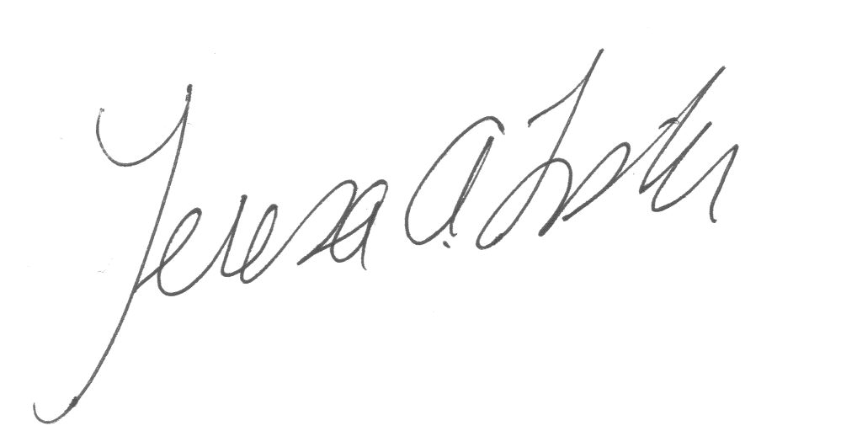
Teresa A. Fisher, Recording Secretary
Handouts: agenda, Dean’s List and President’s List spreadsheet and email
Recording: https://us02web.zoom.us/rec/share/kwVvRuGE657MOk8zI7EPvp-PArH0JmdnmcGCqXGb1EQ_G9WBZJ2k_CvGGIa9HM_B.xQbp4RdwovebHXkh Passcode: XBVP0#85

