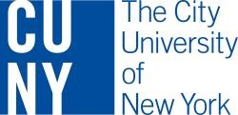

**THE CITY UNIVERSITY OF NEW YORK**

**Application for Fellowship Award**

**Eligibility**: The following titles are eligible for the award of a fellowship leave: Tenured Assistant Professor, tenured Associate Professor, tenured Professor, tenured College Laboratory Technician, tenured Senior College Laboratory Technician, tenured Chief College Laboratory Technician, in the Hunter College Campus Schools, tenured Teacher, tenured Guidance Counselor, tenured Campus Schools College Laboratory Technician, and tenured Campus Schools Senior

College Laboratory Technician, tenured Assistant Medical Professor (Basic Sciences), tenured Associate Medical Professor (Basic Sciences), tenured Medical Professor (Basic Sciences), tenured Assistant Medical Professor (Clinical), tenured Associate Medical Professor (Clinical), and tenured Medical Professor (Clinical), tenured Law School Assistant Professor, tenured Law School Associate Professor, tenured Law School Professor, tenured Law School Library Assistant Professor, tenured Law School Library Associate Professor, tenured Law School Library Professor, Lecturer with a Certificate of Continuous Employment (CCE), and Lecturers with a CCE on leave from that title, serving in an untenured professorial title.

The individual must have completed six (6) years of continuous paid full-time service with the University, exclusive of fellowship leaves and most other leaves. Full-time contiguous service as a substitute counts as service towards fellowship leave.

**Purpose**: Application for a Fellowship Award may be made for research (including study and related travel), improvement of teaching, and/or creative work in literature or the arts.

**Duration**: Application may be made for a Fellowship Award for (1) a full year leave at 80% of the biweekly salary rate, (2) a one-half year at 80% of the biweekly salary rate, or (3) one-half year at full pay.

***HR must verify eligibility for Fellowship Award Application prior to the submission of the application to the academic department.***

Bronx Community College

**I.**

**Employee Information:**

Name

Title

Department

Empl ID

Date of Tenure

Date of CCE*

*\* Applies to individual serving in title of Lecturer with CCE*

*and to an individual on leave from the title of Lecturer*

*with a CCE who is serving, without tenure, in the title of*

*Assistant Professor, Associate Professor or Professor.*

Date of initial appointment to the University

Date of appointment to current title

College

**Indicate dates and purpose of all previous leaves of a semester (or more) for the prior ten (10) years.** (*Attach additional pages, as necessary)*

Date from

Purpose

**II.**

**Fellowship Award Information**

Date to

Purpose

Date to

Date from

Purpose

Date to

Date from

Purpose

Date to

Date from

Purpose

Date to

Date from

**A. Duration and dates of the proposed leave:**

Full year at 80% of biweekly salary rate

Half year at 80% of biweekly salary rate

Half year at full pay

Semester 1

Semester 2

Semester

Semester

**Eligibility Verified**

HR Director

Signature

Date

OHRM-Instructional Staff Academic Leaves - Fellowship Leave Form - Revised March 2016 Page 1 of 4

1. **Briefly describe the purpose or purposes of the proposed Fellowship Award:** *(Attach additional pages, as necessary)*

Research

(

including study and related travel

)

Improvement of teaching

Creative work in literature or the arts

1. **Briefly describe any activities which you have undertaken and/or completed to date in conjunction with the proposed Fellowship**

# **Award:** (Attach additional pages, as necessary)

None 

**D. List the location (s) where the activities associated with the proposed Fellowship Award will occur:**

# (Attach additional pages, as necessary)

# **E. Outside sponsorship and/or service:** (Attach additional pages, as necessary)

i) Will any of the activities associated with the proposed Fellowship Award be sponsored or facilitated by an institution other than The City  University of New York?

*If yes, please name the institution(s) and describe the nature of the sponsorship or facilitation (i.e., laboratory privileges, use of private archives or collections, collaboration with staff, etc.).*

No Yes

*If yes, please name the institution(s), describe the service which you anticipate performing and state the nature and amount of any compensation which you expect to receive for performing such service:*

No Yes

ii) Do you anticipate performing a service for any institution other than The City University of New York during the proposed leave?

iii) List the nature and amount of any funding for the proposed Fellowship Award (other than your University salary and personal resources) which you have been awarded or for which you have applied or intend to apply:

None

OHRM-Instructional Staff Academic Leaves - Fellowship Leave Form - Revised March 2016 Page 2 of 4

**III. Attestation of Applicant:**

I acknowledge the following:

1. Fellowship Award applications are processed in accordance with the policies of the Board of Trustees of The City University of New York and the Agreement between the Professional Staff Congress and the City University of New York.
2. The information provided is accurate. Should the stated purpose of my leave change, or become unable to be accomplished, even if I have commenced the leave, I shall immediately notify the president in writing. Should the president determine that the purpose of the leave is no longer served, the leave may be terminated, with the assignment of appropriate duties at the college, or other appropriate action.
3. Should I be awarded a full-year fellowship leave at 80% of the biweekly salary rate, I may, at my option, upon written notice to the president no later than October 30 or March 30, whichever is applicable, terminate the fellowship leave after one-half year. If a full-year fellowship leave is so terminated, such termination relieves the University of any obligation to further claims for the second half of the leave, but does not reduce the time period or other qualifications required for consideration for a subsequent fellowship leave.
4. By accepting a fellowship leave, I am obligated to serve at The City University of New York for at least one year following the expiration of the leave, unless that requirement is expressly waived by the Board of Trustees.
5. Within thirty (30) days following the expiration of my fellowship leave (except leave for purposes of restoration of health), I shall submit to my department chairperson a summary, in writing, of my relevant activities during the leave.
6. I acknowledge that my obligation under The City University of New York Intellectual Property Policy to disclose to the University any University-owned intellectual property extends to intellectual property that I create during this leave.
7. I understand that while on leave, employment within or outside the University is prohibited, unless such involvement is integral to the purpose for which the leave is granted, or there is a compelling justification, and may be engaged in only with prior approval of the president.

Address

Country

Email

Zip Code

State

City

Tel.:

**Contact information during the Fellowship Leave:**

Date

Signature

**IV. To be completed by the Department Chair**

**Briefly describe how the applicant’s stated purpose for the Fellowship Award is consonant with the mission of the department and college:**

**How does the department intend to cover the applicant’s courses and related responsibilities at the college during the period of the proposed leave:**

OHRM-Instructional Staff Academic Leaves - Fellowship Leave Form - Revised March 2016 Page 3 of 4

## V. Recommendations of Personnel & Budget Committees: (Department, Division, School, etc.)

*Note: Approval of the Fellowship Award is an endorsement that the work of the department in which the applicant serves can be so arranged as to be carried forward effectively during the period of the leave, and that the work the applicant intends to do is consonant with the principles of the Fellowship Award.*

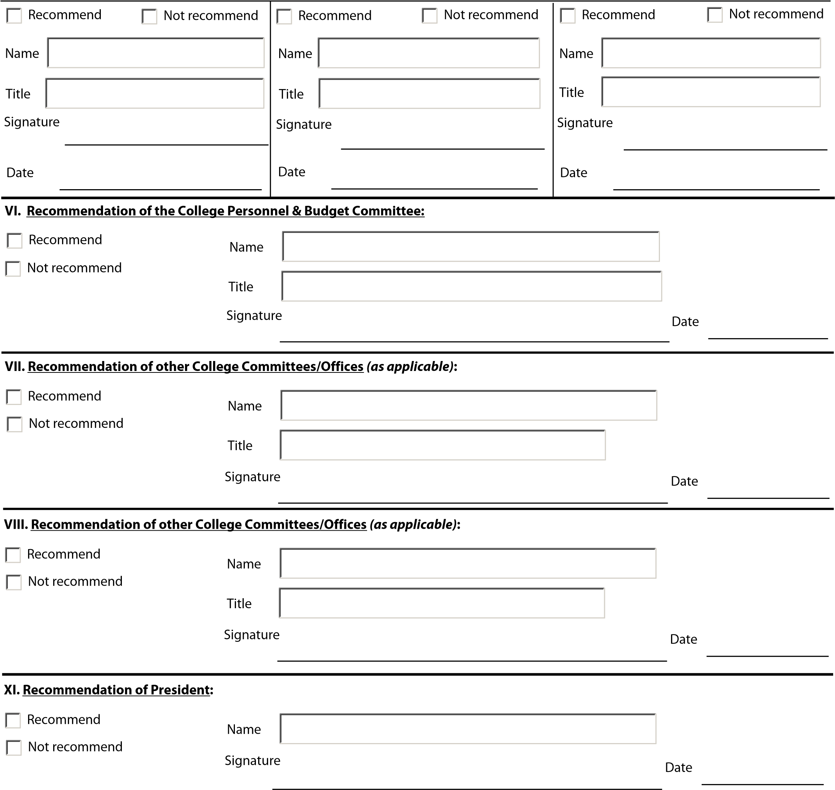

Chancellor's University Report Date

OHRM-Instructional Staff Academic Leaves-Fellowship Leave Form - Revised March 2016 Page 4 of 4