BRONX COMMUNITY COLLEGE

of the City University of New York

Committee on Academic Standing
Minutes of February 9, 2022 (web conference [Zoom])

Present: Rasheen Allen (Bio), Laurel Cummins (World Lang), Teresa Fisher (CommAS), Anthony Gatto (A&M), LaChoy Harris (Stu), Janet Heller (HPER), Kamal Ismail (Chem), Paul Jaijairam (Bus), Noah Jampol (Eng), Mehdi Lejmi (Math), Eugene Mananga (Eng Phy Tech), Octavio Melendez (Adv, OAA), Stephen Powers (Edu), Elena Robin (SGA; 2:22 arrival, left before 2:45pm, back at 3:06pm), Wladyslaw Roczniak (Hist), Marjaline Vizcarrondo (Soc Sc), James Watson (Library)
Present Alternates: Gregory Cobb (Soc Sc), Carlos Cruz (CommAS), Michael Hodges (HPER), Ivan Horozov (Math), Edward Lehner (Edu), Anita Rivers (Reg) – seated, Soosairaj Therese (Chem)
Guests: Cheryl Byrd (Appeals Agent), Jessica Cabrera (ASAP), Cynthia Suarez-Espinal (CD), Alexander Ott (OAA)
Absent/Excused: Angel Calderon (Stu), Kenneth Flowers (SGA), Sierra Moncayo (Stu), Vivian Rodriguez (Nurs), Karen Thomas (Reg)

- Call to Order: At 2:04 P.M., meeting called to order by S. Powers. The meeting was recorded.
- Approval of the December 8, 2021, minutes: The minutes from 12/08/21 were approved as amended by the 15 seated members present who were at that meeting. E. Robin arrived after the vote.
- Student Appeals: C. Byrd reported there were 171 appeals: 89 denied, 79 granted, and 3 are in review. The granted appeals are being adjusted by the Registrar while the students whose appeals were denied have been notified. Members voted to approve the granted appeals as approved by the sub-committee. The vote was approved unanimously by all seated members present.
- Changes to the codification: S. Powers updated on the changes that were approved by the Board of Trustees and made to the codification (see agenda). The codification was updated and will be uploaded to the BCC website. Many of the changes were related to changes necessitated by the CUNY uniform grade policy memo from May 2021.
- Dean’s List and President’s List Revisions: A Ott updated the members on the proposed changes, which have changed significantly from the previous proposal based on members’ feedback (see agenda). The Dean’s List for graduation and the President’s List for graduation are recommended for elimination as they are not being used. Additionally, the creation of graduation honors notation to be placed on the transcript is proposed by the sub-committee. Discussion ensued. Departments were asked to return the proposal to their departments for discussion.
- The WU grade: T. Fisher presented concerns raised in her department about the WU grade since the May 2021 CUNY uniform grade policy memo (see agenda). S. Powers added that the phrase “completely stopped attending” is also problematic as a student could miss most of the classes but show up the last day of class and then they would no longer have stopped attending. O. Melendez reminded that students now also have the ability to withdraw officially until the last day of class, which also complicates the situation. K. Ismail noted that bullet point 6 under 8.3.1bi says “a faculty member”, which is further confusing as it doesn’t specify the student must speak to the faculty member attached to the class in question. Discussion ensued including a discussion of the CR/NC COVID-19 grades and their impact on students. While the CR/NC was helpful for students for students’ GPA, it could have longer-standing ramifications dealing with external agencies and transfer institutions. In order to address the issue, a small sub-committee could be formed or feedback could be sought from departments first before moving forward with changes, if any. T. Fisher will lead that sub-committee with P. Jaijairam, O. Melendez, and R. Allen also serving on it.
- New Business: S. Powers reported on the recommendation from a sub-committee that met in January regarding a student who appealed the result of an academic grade appeal under the grounds that the appeal process was not correctly followed by the World Languages department. Upon review, the sub-committee agreed that the process had not been followed and recommended the department hear the appeal again. Members voted to approve the sub-committee’s recommendation. The recommendation was approved unanimously by all seated members present.
- Adjournment: 3:24 p.m.

Meetings are held on the 2nd and 4th Wednesday of the month. Spring 2022 dates: 2/23, 3/9, 3/23, 4/13, 4/27, and 5/11.

Respectfully Submitted,
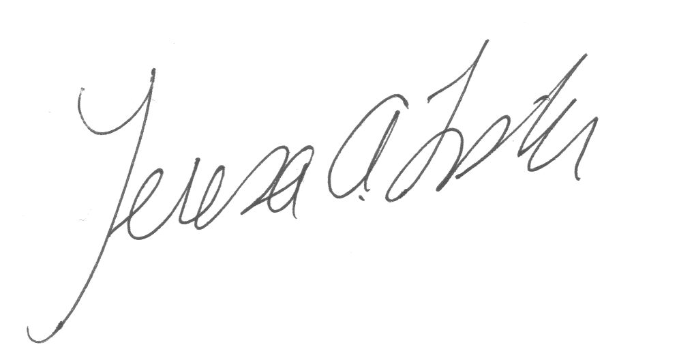
Teresa A. Fisher,
Recording Secretary

Handouts: agenda
Recording: https://us02web.zoom.us/rec/share/yhibCAOvg0Gm6hMM85nY891LLgv4BoQCadPiJtWAqr2YdSypTqWXVxjAHNc7TtGT.wVPP2Ax0GRkd_3b_ (Passcode: 6cZ@UQTC)

