BRONX COMMUNITY COLLEGE

of the City University of New York

Committee on Academic Standing
Minutes of February 23, 2022 (web conference [Zoom])

Present: Rasheen Allen (Bio), Angel Calderon (Stu), Laurel Cummins (World Lang), Teresa Fisher (CommAS), Kenneth Flowers (SGA), Anthony Gatto (A&M), Janet Heller (HPER), Kamal Ismail (Chem), Paul Jaijairam (Bus), Noah Jampol (Eng), Mehdi Lejmi (Math), Eugene Mananga (Eng Phy Tech), Octavio Melendez (Adv, OAA), Stephen Powers (Edu), Elena Robin (SGA), Wladyslaw Roczniak (Hist), Vivian Rodriguez (Nurs), Marjaline Vizcarrondo (Soc Sc), Karen Thomas (Reg), James Watson (Library)
Present Alternates: Nefertiti Cano (Nur), Gregory Cobb (Soc Sci), Michael Hodges (HPER), Edward Lehner (Edu), Anita Rivers (Reg) – seated, Soosairaj Therese (Chem)
Guests: Cynthia Suarez-Espinal (CD)
Absent/Excused: LaChoy Harris (Stu), Sierra Moncayo (Stu)

- Call to Order: At 2:07 P.M., meeting called to order by S. Powers. The meeting was recorded.
- Approval of the February 9, 2022, minutes: The minutes from 2/09/22 were approved as amended by the 17 seated members present who were at that meeting.
- Student Appeals: S. Powers updated on appeals and the appeal process in Cheryl Byrd’s absence.
- Dean’s List and President’s List Revisions: (see agenda) O. Melendez reported no changes from what was previously presented. CAS is waiting for feedback from departments as departmental meetings have not yet happened since the last CAS meeting. Discussion ensued. E. Robin reported students have asked about having more than one person sending emails to students about their inclusion on either list as they are reporting delays in receiving notification. O. Melendez will follow up with Edwin Roman and OAA about this. E. Robin also reported that students wondered if there could be a “Vice-President’s/Provost’s List” for students with a 3.0 and lower GPA (they don’t have a bottom GPA threshold determined) as an incentive for students who don’t meet the President’s or Dean’s Lists. Discussion ensued.
- WU policy proposal: (see agenda and handouts) T. Fisher presented the sub-committee’s draft and a flow chart regarding clarifying language for the recently updated WU policy (from the May 2021 CUNY uniform grade policy memo). Questions were asked and discussion ensued. A preference for the flow chart was noted, but the need to make sure the codification is clear was also reiterated. Additionally, consideration for how all faculty – full-time and adjuncts – will have ready access to this information was noted as a concern. Members were asked to discuss this with their departments. The sub-committee will review the feedback and revise then report back to the committee at the 3/9 meeting.
- Update on Prior Learning Assessment (PLA) or CPL (credit for prior learning): S. Powers provided a brief update.
- New Business: None.
- Adjournment: 3:26 p.m.

Meetings are held on the 2nd and 4th Wednesday of the month. Remaining spring 2022 dates: 3/9, 3/23, 4/13, 4/27, and 5/11.

Respectfully Submitted,
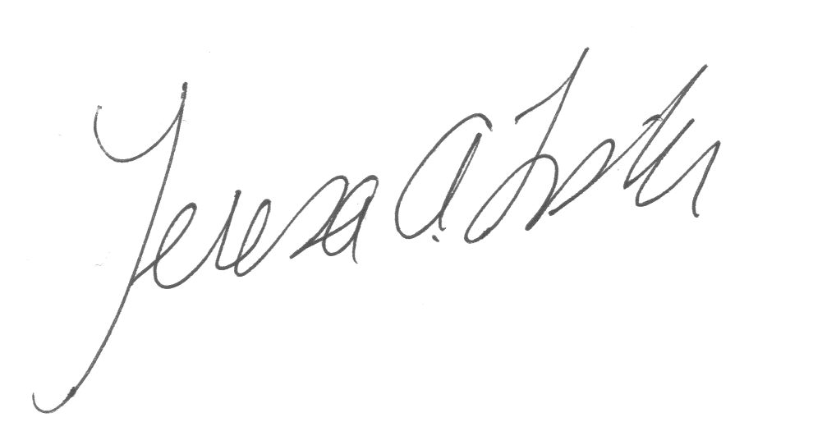
Teresa A. Fisher,
Recording Secretary

Handouts: agenda, WU draft policy x2, flowchart
Recording: https://us02web.zoom.us/rec/share/LmhEfs2D4tufjwPMvial2mzb-K-CKtXZlQSYe6KzyUm2AK2lG3IKHCgV3_veIQ.tQf5_KSJ7XROf5IB Passcode: 8&XsjZm6

