COMMITTEE ON ACADEMIC STANDING
April 13, 2022: 2:00 – 4:00

Zoom Meeting Link:
https://us02web.zoom.us/j/88250189787

AGENDA

- Call to order Steve Powers

- Approval of Minutes from 3/23/2022 Teresa Fisher

- Student Appeals Cheryl Byrd
  - Report

- The WU grade Teresa Fisher
4.A. The WU grade and possible action from the Senate Chairs Steve Powers
across CUNY: the punitive value of the WU,

- Residency for Certificates (3rd meeting) Alex Ott

- Formation of a Committee, from AcMo 2.0 *the CUNY Alex Ott
transfer group), to discuss F replacement policy at CUNY
Volunteers needed, materials to be distributed

- Proposed amendment to the FYFFP (1st meeting) Steve Powers
Email was sent to the committee members on 4.11.22, and the
issue was presented to chairs on the morning of 4.13.22

- New Business

Remaining Spring Dates:

April 27, 2022
May 11, 2021
What Grade Should I Give?
A Pictorial Representation (followed by more nuanced explanations)
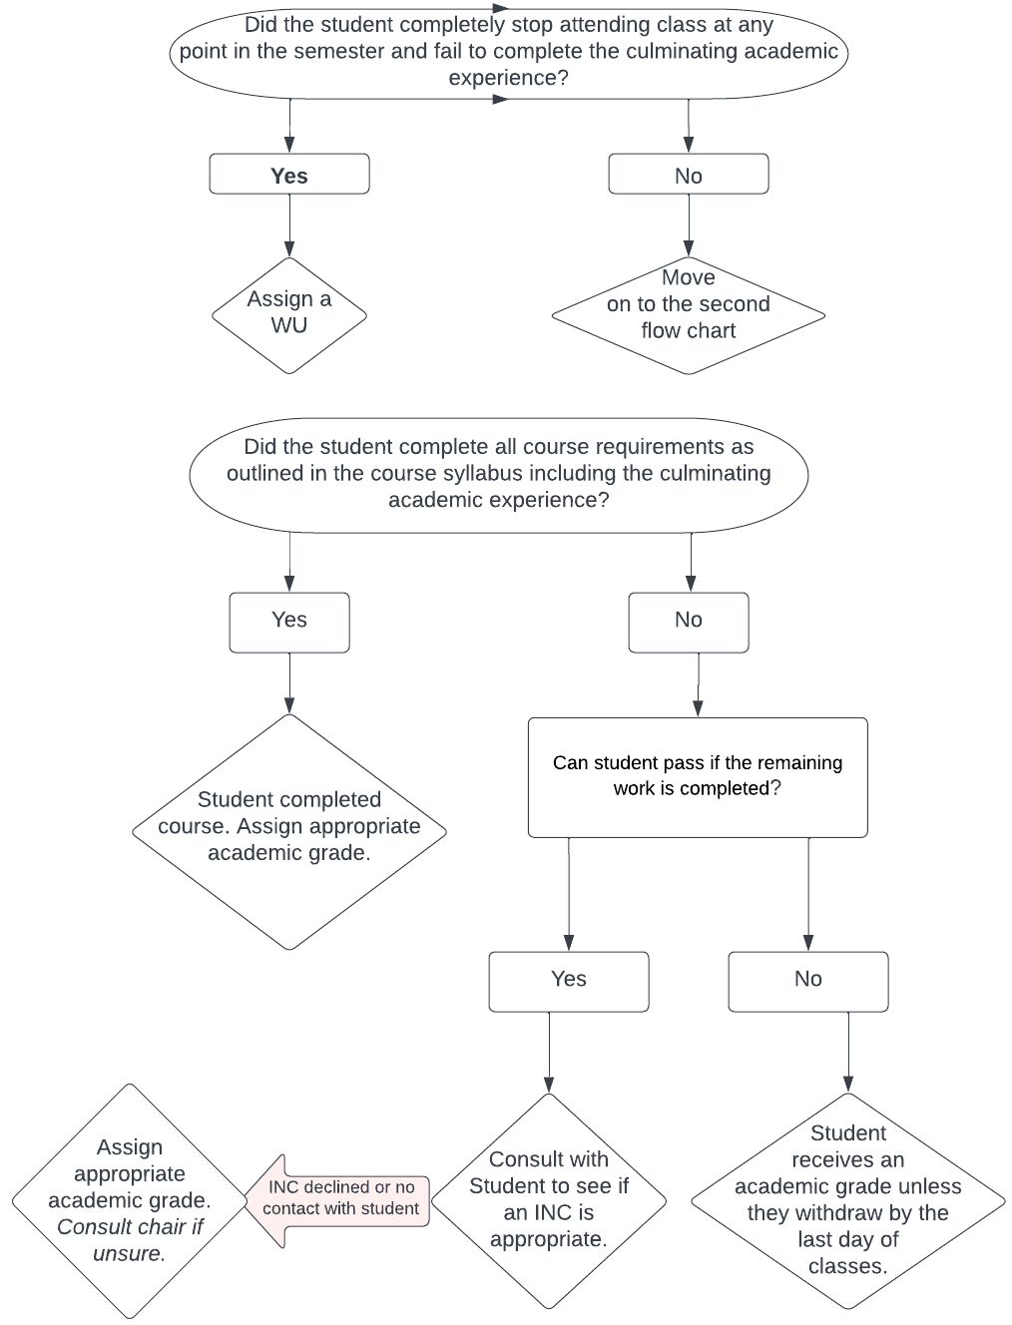

What Grade Should I Give?
This document is provided to faculty as a guide to help you navigate the assigning of student grades as well as to explain grading-related policies. This guide will help you in determining what is the appropriate grade to give based on CUNY’s uniform grading policy (as modified in May 2021 and in effect starting with the Fall 2021 semester).

Grades within approximately the first three weeks of the semester (administrative grades only):
- WN (withdrew, never attended): A WN is assigned to a student when they have never attended a class and, more specifically, have never participated at least once in an academically related activity. You can find a list of “academically related activities” in the Academic Rules and Regulations (the “codification”) as well as listed in the Verification of Enrollment (VOE) instructions. When this grade is assigned, a student has to pay back any financial aid they may have received for the course.
  - Can I reverse a WN? Yes, but consult with your department chair to see if you should.
- WD: This is student-generated and means they dropped the class of their own volition.
- WA: This is the immunization withdrawal and requires that a student submit the appropriate documentation to Health Services in order to be reinstated.

Final Semester Grades (academic, administrative, and temporary grades):
- A through D-: These are passing academic grades that are assigned when a student has achieved the grade through completing the coursework of a class, as outlined in the syllabus.
  - What if a student wants to appeal an academic grade? There is an appeal process that they must go through that is arranged by the relevant academic department for the course. In the Academic Rules and Regulations, this is codified in 8.8.3 (see link at end of this document).
  - What if the student didn’t complete the culminating experience (e.g. final exam)? Is an INC (incomplete) appropriate (see INC section)? Has the student completed a sufficient amount of the course (e.g. 80%) so that, just factoring in the work completed without the final exam the student still has a passing grade that could be assigned, particularly if there is no contact from the student? Or is a WU an appropriate grade if the student also missed the last class session (see WU grade section)?
    - An example: One semester, a faculty member had a student who earned a high A grade in 80% of her work but failed to show up for the final exam. The student was pregnant at the time as well as raising a toddler. The faculty member was able to reach the student via email and asked if the student would like an INC (incomplete) to take the final exam at another time, but the student did not feel she would be able to do so. The faculty member noted that, even with a “0” for the final exam, the student still had earned enough points for an overall C+ grade in the class. The student said she would be happy with the C+ grade and so that was entered as the final grade. Note that this scenario was dependent on the student consulting with the faculty member and a passing grade with a zero calculated for the culminating academic experience. As per CUNY’s INC policy, a faculty member cannot assign an INC grade without consulting the student.
- P/NC: BCC has a Pass/No Credit policy that allows students to take up to two of their BCC courses as pass/no credit. Students must initiate this by asking faculty if they can do so (there is a deadline of the last day of classes for them to submit the form, a form faculty must sign). Faculty are not obligated to accept this request. For example, if a faculty member knows the student taking the course needs a specific grade in order to meet program requirements, they will rightfully refuse the request. If you’re uncertain, talk with your department chair.
- F: The F is an earned academic grade in which the student has, according to CUNY’s uniform grade policy, either completed the course requirements but that work is at a failing level or the student has completed a sufficient amount of the course work at a failing level that even if the student completed the remaining work, their grade would still be an F.
  - But what about giving a WU instead of an F if the student’s work isn’t completed? If the student meets the WU requirements (see WU section), then a WU would seem to be appropriate. But, as per CUNY’s uniform grade policy, if it’s clear by adding up the points that even if the student completed the remaining work there was no way for them to pass the class, then the F is considered the appropriate grade. What’s the difference? In the case of a WU being appropriate, the student may have only completed a minor portion of the work (for example, 25%) before they stopped attending so that one cannot conclusively make a determination that completing the remainder of the work would have resulted in an F grade. But if the student has completed, for example, 70% of the coursework and at a failing level, that is a clearer pattern (and, indeed, mathematically, an F may be the only possibility even if the other 30% were to be completed). This would be a good situation to ask for guidance from the Committee on Academic Standing (see link at the end of this document) to help you determine the appropriate grade.
- W: A withdrawal is a student-initiated grade. Students have to login to CUNYFirst to complete the withdrawal process. They have until the last day of classes (before final exams begin) to drop with a W. After that date, they have lost the opportunity to do so.
  - What if a student submitted the W earlier in the semester and then changes their mind (or says it was an accident) so asks me to reverse a W grade? You will need to consult with your department chair, as such a change will have to go through the Registrar and requires chair approval. If it was indeed an accident or you believe the student could successfully pass the class if allowed back in, you can choose to support the student’s request and advocate that to your chair.
- WU: The WU grade means a student completely stopped attending the course at any point in the semester and also didn’t complete the culminating academic experience (e.g. final exam, final paper). It means the student unofficially withdrew from the class.
  - An important note about how the WU is now versus pre-fall 2021: The WU has changed since the fall of 2021. Prior to fall 2021, the WU had the same academic impact as an F on a student’s GPA. Now it has no impact on a student’s GPA.
  - What does “completely stopped attending at any point in the semester” mean? It could be the student attended once in the first 3 weeks so passed the VOE, but then didn’t attend again. Or perhaps the student attended regularly through the midterm exam but stopped after that, or…well, there are lots of scenarios here. One clear barometer is that if they were in class on the last day of class, they don’t meet the requirement for a WU. Which means they could have missed 30 hours of class but decided to show up on the last day and they are ineligible for a WU, even if they don’t take the final exam.
  - What if my class doesn’t have a final exam or final paper or another designated culminating academic experience? You’ll need to consult with your department chair and/or the Committee on Academic Standing (see link at end of this document) to figure out the best way to resolve this situation.
  - Can a student appeal an administrative grade? Yes. Administrative grade appeals are handled through the Committee on Academic Standing (CAS) (see appeal section and link at the end of this document).
- INC: The INC (incomplete) is a temporary grade assigned in consultation with the student. There must be a reasonable expectation that the student can complete the remaining work and successfully pass the class once they have done so.
  - How long does a student have to complete the INC? Until the last day of classes of the next semester (summer doesn’t count so a spring semester INC has until the last day of classes in the fall semester to be completed).
  - What happens if a student doesn’t complete the INC? The INC turns into a FIN (failed to complete), which has the same impact on their GPA as an F grade. This is why students should not enter lightly into an INC. In some situations, particularly if they have more than one final piece of the course to complete, the W is the more appropriate grade and students can be encouraged to drop (unless there is a reason why they cannot – see “things to consider” section).
  - What if a student wants to appeal an INC or FIN? The student should first contact the instructor. They can also go to the department chair if they are unable to reach the professor. Finally, as per 8.8.5 in the Academic Rules and Regulations, they may also seek help with the Committee on Academic Standing (CAS) (see links at the end of this document).

Things to consider:
- Is the student receiving military veterans’ benefits? If yes, they must complete their classes with a letter grade. Failing to do so means they will need to pay back their benefits. As such, make sure when advising students on their options to ask them, “Are you a military veteran utilizing veterans’ benefits to pay for school?” If the answer is “yes”, make sure they know that they have to complete the course requirements including completing the culminating academic experience in order to receive an academic grade. If they fail to do so, you must give them the appropriate grade, even if that is an administrative grade.
- Is the student planning to enter or already in a program that requires a specific grade for certain classes? Nursing and Allied Health students (RN, LPN, MLT, Rad Tech, etc.), some Business and Information Services students, and a few other select programs require a specific grade in some classes. There is also often a limit on the number of times a student can take those classes. Failing to earn that grade and/or going over the allowable attempts (with W, WU, and even WN sometimes counting as an attempt) will result in ineligibility to enter the desired program or dismissal from it. This also means if a student wants to take your clas55s as P/NC, they should not do so if they need a specific letter grade for their program of study. Faculty are often aware if the course they are teaching falls into one of those categories, but it would be good to check with your department chair if you’re not sure.
- Will the student be academically harmed by the grade I’m awarding them? Inevitably, a failing or below-a-C grade can hurt a student, but there might not be anything you can do about it. If you’re wondering about other options you haven’t explored or understood, talk to your CAS (Committee on Academic Standing) representative (or to the Chair of that committee, Dr. Stephen Powers, see link at end of this document). Maybe there is a nuance between an F and a WU, for example, that you’ve missed.
- Is the student receiving financial aid? This falls into the category of information you can’t really do anything about, but it’s probably good to be aware of as we have many students who don’t realize the harm they are causing themselves from too many attempted and not enough earned credits. While administrative grades like the WU and W, P and NC grades, as well as the academic appeal process (see next section) offer students the ability to maintain an appropriate GPA (students must have at least a 2.0 GPA to graduate), when it comes to financial aid, there are two measurements that the federal/state/local governments consider when determining if a student is still eligible for financial aid. GPA is one and the other is “pace of progress”. In short, the ratio between credits attempted (which includes all academic and administrative grades even the W) to credits earned. In sum, for a 60-credit degree, students cannot attempt more than 90 credits for that degree (a change of major is one way to help overcome a pace of progress issue).

What are academic appeals? How do students apply for them?
There are a variety of remedies available to students at BCC to help them rehabilitate their academic status and achieve success at BCC. It can be useful to be familiar with them as students are not always aware of them or may ask you questions about them. Students should seek out the Academic Appeals Agent (Cheryl Byrd) for assistance with academic appeals (see link at end of this document).
- F-replacement: For up to 16 credits at BCC, in the calculation of their GPA, students can replace an F grade with a C or better in another attempt at that same class. For example, a student gets an F in COMM 11 in spring 2022, takes the class again in fall 2022 and earns a B in it. The F from spring 2022 is replaced in the student’s GPA by the B from fall 2022. This is done automatically. The student does not need to request the change. Please note that F-replacement should be honored at other CUNY schools but is not likely to be honored beyond CUNY. So prior F grades will be recalculated into a student’s GPA when they are transferring to a non-CUNY school.
  - What about a D-replacement? This doesn’t exist. It’s why we often say that a D is worse than an F at BCC. This doesn’t mean you can give a student an F when they earned a D, of course, but it’s important to be aware of the difference as there has been misinformation passed around over the years that it is possible to replace a D with a higher grade but it is not. The only time a non-F grade can be replaced involves specific programs (e.g. Nursing and Allied Health) that have specific grade requirements for specific courses. And, even then, in some cases, both attempts for a course – both the D and the B, for example – are factored into a student’s GPA rather than the higher grade replacing the lower one.
- First Year Freshman Forgiveness Policy (FYFFP): Students in their first year of study can appeal to change up to 12 credits within that first year from F to NC (does not apply to transfer students unless they only had one semester of previous college study; students who took classes as a non-matriculated student while in high school are eligible for FYFFP). Students need to meet with an advisor to create an official academic plan as well as write a personal statement. (see link at end of this document)
- Statute of Limitations: Students with grades older than 7 years may appeal to replace them in GPA calculations with an equal number C level or better credits (e.g. D in ECO 11 in spring 2012 could be replaced with a C in ENG 147 from fall 2019). Please note that statute is not likely to be honored by other schools including within CUNY. So prior poor grades will be recalculated into a student’s GPA when they are transferring. Students will need to submit a personal statement and transcript. (see link at end of this document)
- WU appeal: For WU grades prior to fall 2021, students may appeal them with appropriate documentation and a personal statement. (see link at end of this document)

Links:
- Academic Rules and Regulations (the codification): http://www.bcc.cuny.edu/wp-content/uploads/2022/02/bcc_academic_rules_and_regulations_feb22.pdf
- Academic Appeals: http://www.bcc.cuny.edu/academics/academic-advising/academic-appeals/
- Committee on Academic Standing: http://www.bcc.cuny.edu/about-bcc/college-senate/committee-on-academic-standing/

Revision: To amend the FYFFP to have no limit to appealed grades for the 2020 calendar year.
First Year Freshman Forgiveness Policy  8.8.6 First Year Freshman Forgiveness Policy (Effective for courses offered in Fall 2019 and subsequent  semesters only.)  a. Per the CUNY Uniform Grade Glossary, “A college may choose to offer a First Year Freshman  Forgiveness policy. If the student passes the course, they will receive the grade earned which will carry the designated GPA. If the student fails the course, the grade will be administratively converted to NC and have no impact on the GPA. This policy is limited to first year freshman as defined by the college.” BCC adopts this policy with the following restrictions and clarifications:  i. For the purpose of this policy, BCC defines a first-year freshman as a student that is within their first two matriculated semesters at the college-level  ii. A limit of 12 forgiveness credits may be applied within that first year  iii. A grade of F, WU, FIN can be converted to an NC as per CUNY guidelines  iv. The student must request this administrative conversion in writing to the Committee on  Academic Standing (CAS) via the standard grade appeal form. This request must be  accompanied by an academic plan prepared by an advisor or faculty member. If the  appeal is approved, it is forwarded to the Registrar’s Office for changes to the student’s  permanent record.  v. Students who are forgiven less than 12 credits, can use the limit of 6 P/NC credits to a  maximum total of 12 credits.  A student who is Forgiven Can use:  3 credits 6 P/NC credits  6 credits 6 P/NC credits  9 credits 3 P/NC credits  12 credits 0 P/NC credits | First Year Freshman Forgiveness Policy  ii. For the calendar year of 2020 the limit of 12 credits will not apply
Effective: Fall 2022

Rationale:
Due to the Covid-19 Pandemic conditions, and aligned with the Chancellor’s Flexible Grading Policy for spring 2020 and fall 2020, we are seeking to waive the limit of 12 credits for the period of the calendar year of 2020, due to the extraordinary circumstances faced by students during this period.

