BRONX COMMUNITY COLLEGE

of the City University of New York

Committee on Academic Standing
Minutes of October 26, 2022 (Loew Hall, 200)

Present: Bernice Agyeiwaa (SGA), Rasheen Allen (Bio), Candise Clarke (SGA), Laurel Cummins (World Lang), William DeJong-Lambert (Hist), Julian Espinosa (Stu), Teresa Fisher (CommAS), Kamal Ismail (Chem), Noah Jampol (Eng), Mehdi Lejmi (Math), Eugene Mananga (Eng Phy Tech), Octavio Melendez (Adv, OAA), Stephen Powers (Edu), Vivian Rodriguez (Nurs), James Watson (Library)
Present Alternates: Carlos Cruz (CommAS), Gregory Cobb (SocSc -- seated), Edward Lehner (Edu), Anita Rivers (Reg -- seated), James Simpson (Bus -- seated)
Guests: Alex Ott (OAA), Annette Ortiz (Nur), Cynthia Suarez-Espinal (CD), Charlotte (Stu, arrived at 2:40pm)
Absent/Excused: Anthony Gatto (A&M), Janet Heller (HPER), Paul Jaijairam (Bus), Veronica Rivera (Stu), Marjaline Sosa (Soc Sc), Karen Thomas (Reg)

- Call to Order: At 2:02 P.M., meeting called to order by S. Powers.
- Approval of the October 12, 2022, minutes: After a motion by O. Melendez, the minutes from 10/12/22 were approved unanimously by the members present.
- Appeals report: S. Powers noted they are on-going.
- Rad Tech proposal: (see agenda) V. Rodriguez and A. Ortiz were present to answer any questions or comments, but there were none. S. Powers did clarify, if passed, it would go into effect in Fall 2023 (not Spring 2023 as noted on the proposal).
- New Business: S. Powers reported on a query raised by Seth Offenbach from the History department questioning the efficacy of and need for midterm grades. S. Powers noted that perhaps moving the midterm grades to a bit later in the semester may be useful given how close the early progress reports and midterm grades currently are. T. Fisher reminded that his query uncovered an error in the codification, 8.7.2, as WU and P grades were listed as possible midterm grades, which is incorrect. Discussion ensued about midterm grades as well as student success in general. V. Rodriguez queried regarding students not allowed on campus due to COVID-19 testing. A. Ott reminded that this is a CUNY policy, not a BCC-specific one so change has to happen at the CUNY level. Emails will be sent by A. Ott and S. Powers expressing the concerns raised by the members.
- Adjournment: After a motion from R. Allen, the meeting adjourned at 2:51 pm.

Meetings are held on the 2nd and 4th Wednesday of the month. The remaining fall 2022 and spring 2023 meetings are: 11/9, possibly 12/7 or 12/14 (see agenda). And for Spring 2023: 2/8, 2/22, 3/8, 3/22, 4/26, and 5/10. Unless otherwise indicated, meetings will take place in Loew Hall, 200.

Respectfully Submitted,
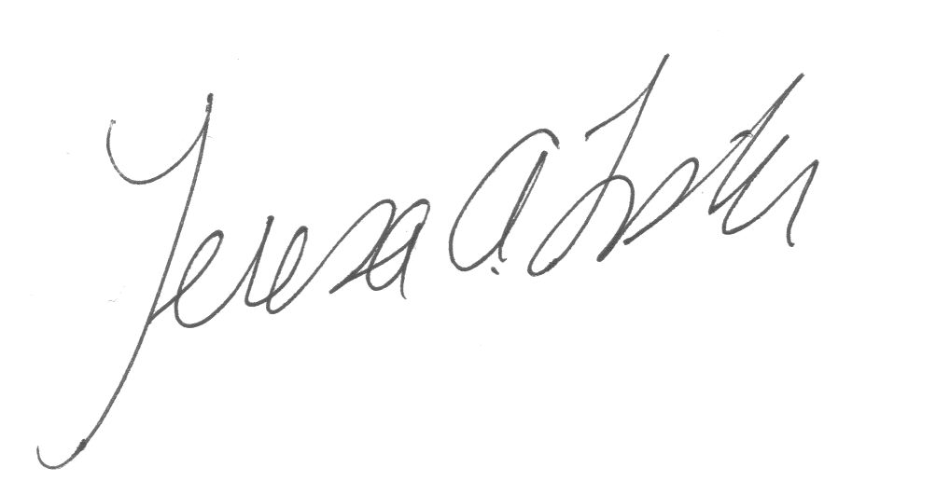
Teresa A. Fisher, Recording Secretary

Handouts: agenda

